**What is an AIM statement?**

An aim statement is a clear, explicit summary of what your team hopes to achieve over a specific amount of time including the magnitude of change you will achieve. The aim statement guides your work by establishing what success looks like.  
  
Research shows teams who develop a good aim perform better. It provides alignment of multiple stakeholders, helps keep the team focused on the tasks at hand, creates the urgency to accomplish the goal, provides a vision of what success looks like, and serves as a predictor of success that *should be revisited and adjusted*, as needed, based on what your team is learning.

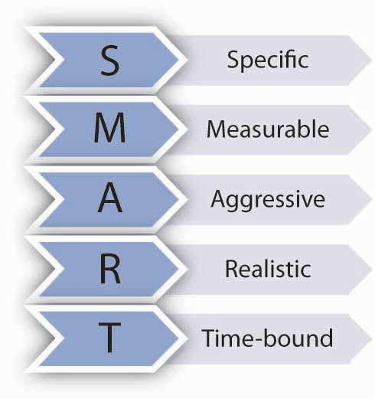

Your team might be familiar with using the **SMART** acronym to create an aim statement. A SMART Aim contains 5 elements: it is **s**pecific, **m**easurable, **a**ggressive, and **a**chievable (a stretch goal), **r**ealistic and **t**ime bound. Alternatively, you can use the **SIMPLE** aim template outlined below.

Here’s some guidance on how to write a great aim statement for your hospital’s CHAMPS National improvement work. As a Steps Team, first, consider:

* Developing goals that aligns with CHAMPS National overarching goals:
  + Increasing the exclusive breastfeeding rates
  + Decreasing breastfeeding disparities by race/ethnicity.
* One or several concrete goals you want to achieve related to the 10 Steps using your baseline data to set the goals to be accomplished, over time.
* Who will benefit from this improvement?
* Where will the change occur?
* When would you like to reach your goal?
* Do you want to include words such as evidence-based, safe care, etc.?

Use the grid below to help you develop an aim statement. Answer “what,” “for whom,” “by when,” and “how much,” then put it all together into a full statement at align with the CHAMPS National goals of improving exclusive breastfeeding and eliminating racial/ethnic disparities in breastfeeding

Example SIMPLE Aim Statement

|  |  |
| --- | --- |
| What? | Improve exclusive breastfeeding rates and narrow breastfeeding disparities, improve STS care and improve rooming in for all vigorous newborn, decrease non-medically indicated supplementation for breastfeeding infants |
| For whom? | All awake and alert women and vigorous newborns born and care for in our birth center |
| By when? | June 2026 |
| Practices aligned with the 10 STEPS: By how much, by when? | 1. Rooming in from 78% to 95% 2. Immediate STS post vaginal births 68% to 98% 3. STS upon entry into recovery room care post C/S from 0 to 75% 4. Non-medically indicated supplements from 58% to 15% 5. Exclusivity rate from 36% to 55% 6. Disparities in breastfeeding outcomes by 20% for all NH Black, Asian and Hispanic mothers, and their infants |

|  |  |
| --- | --- |
| Full statement | By August 2026, Better Care Health Centre’s multidisciplinary team will work together to increase our exclusive breastfeeding rate from 36% to 55% and decrease racial disparities in breastfeeding outcomes by 20%. We will do this by:   1. increasing 24-hour rooming in from 38% to 68% by June 2025 2. increasing immediate STS post vaginal births 68% to 95% by January 2026 3. increasing STS upon entry into recovery room care post C/S from 0 to 80% by May 2026 4. decreasing non-medically indicated supplements from 58% to 20% by August 2026. |

|  |  |
| --- | --- |
| What? |  |
| For whom? |  |
| By when? |  |
| Practices aligned with the 10 Steps:  By how much, by when?  (based on where you are now and where you want to be) |  |
| **Full statement** |  |