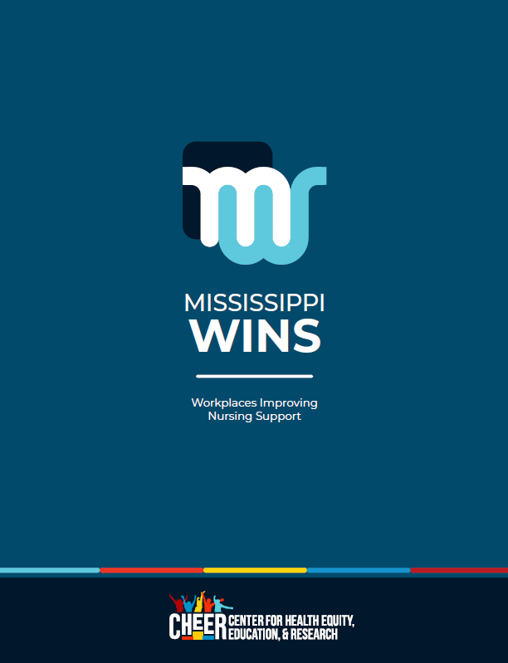
Communities and Hospitals Advancing Maternity Practices

____________ Hospital Employee Lactation Policy

- PURPOSE
Recognizing the well-documented health advantages of breastfeeding for both infants and mothers, [HOSPITAL NAME] provides a supportive environment for lactating employees to express their milk during work hours. No employee will be discriminated against for expressing milk during the work period, and reasonable efforts will be made to assist employees in meeting their infant feeding goals while at work, while also assuring care for patients and other customers.

- SCOPE
This policy applies to all employees of [HOSPITAL NAME] and its wholly owned affiliates, regardless of their classification as exempt or nonexempt. The policy supports Federal law under the Fair Labor Standards Act (FLSA) requiring employers to provide reasonable time and space for breastfeeding employees to express milk during the work period. The policy is included as part of new employee orientation training and family leave planning.

- POLICY STATEMENT
Reasonable Time
- The hospital must provide all breastfeeding employees, regardless of their classification, with reasonable time to breastfeed or express milk during work hours.
- For additional milk expression time required beyond usual meal and break periods, employees can negotiate the time with their supervisor.
- If employees are working during the time they are expressing milk, they must be paid for that time.

Space to Express Milk
- The hospital must provide all breastfeeding employees with a private place(s), other than a bathroom, shielded from view and free from intrusion from co-workers, the public, and any surveillance cameras to express milk.
- The hospital must ensure that employees can use their own private office or other comfortable locations agreed upon in consultation with the employee’s supervisor.
- The space(s) provided by the hospital for breastfeeding or expressing milk must be comfortable, sanitary, and functional for milk expression.

Breast Pump Equipment
- Breastfeeding employees are permitted to request the use of a hospital multi-user breast pump from the lactation department.

Education
- The hospital must ensure that breastfeeding employees are provided with relevant information and resources to help them meet their breastfeeding goals.

Responsibilities of Supervisors
- Unit managers and supervisors must ensure that breastfeeding employees can access lactation support.

Responsibilities of Other Staff
- All hospital employees must engender a positive atmosphere of support for breastfeeding employees and patients.

Responsibilities of Breastfeeding Employees
- Breastfeeding employees must be responsible for maintaining ongoing communication with supervisors about their milk expression needs at work. This includes providing advance notice of their milk expression needs, preferably before they begin maternity leave.
- Breastfeeding employees must assist in keeping the milk expression area clean and sanitary.
- Breastfeeding employees will be responsible for properly storing and handling their expressed milk.

- COMPLAINT/GRIEVANCE PROCESS
To resolve an issue that might occur with employees who express milk in the workplace, staff should first discuss their concerns with a manager or supervisor. If they remain dissatisfied or request to file a formal complaint or grievance, they should refer to the appropriate [HOSPITAL NAME] employee relations department for further discussion and resolution. Employees have the right of private action if they feel their rights to express milk at work have been violated.

- EFFECTIVE PERIOD
This lactation policy will be reviewed at least every 3 years. Ongoing feedback from breastfeeding employees should be used to help determine any improvements needed.

Date Issued:
Dates Revised:
Dates Reviewed:

This sample policy addresses expressing milk during the work period in alignment with Federal FLSA law. Although the hospital setting may not always be conducive to direct breastfeeding, leadership can consider whether direct feeding could be arranged if, for example, the parent’s caregiver is able to bring the baby to the workplace for one or more direct feedings. This could be especially helpful for staff working longer shifts.
U.S. Department of Labor, Wage and Hour Division. Break Time for Nursing Mothers. https://www.dol.gov/agencies/whd/nursing-mothers#:~:text=Federal%20law%20requires%20employers%20to,Section%207%20of%20the%20FLSA).
U.S. Department of Labor, Wage and Hour Division. FLSA Protections for Employees to Pump Breast Milk at Work. https://www.dol.gov/agencies/whd/fact-sheets/73-flsa-break-time-nursing-mothers
U.S. Department of Labor, Wage and Hour Division. FLSA Protections for Employees to Pump Breast Milk at Work. https://www.dol.gov/agencies/whd/fact-sheets/73-flsa-break-time-nursing-mothers

